Admin
- The top part has been cut out, Need to make it pop up (the box)
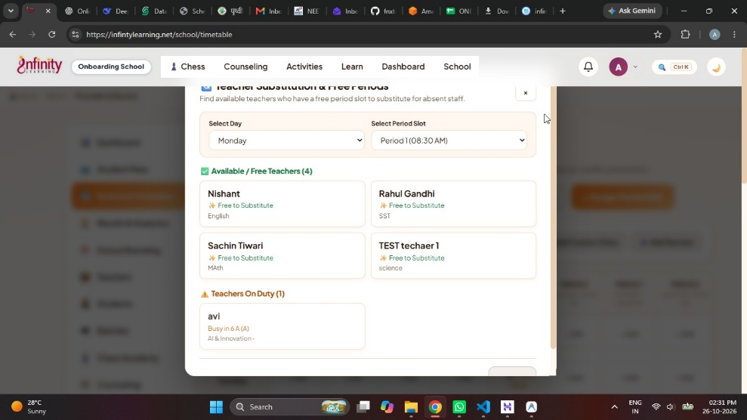
- In student registration the grade will be in a dropdown format from timetable format class format.
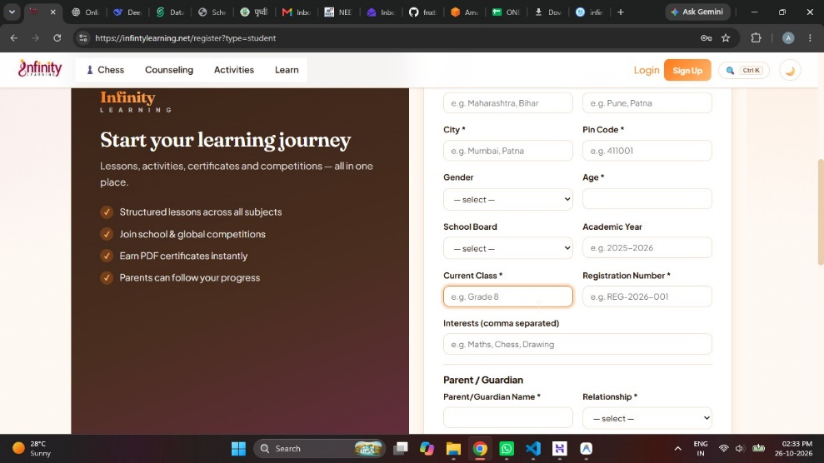
- Need to add scroll. Funtioin on the side bar (same feature for student and teacher)

- In this box we cannot go up and down using the arrow key.
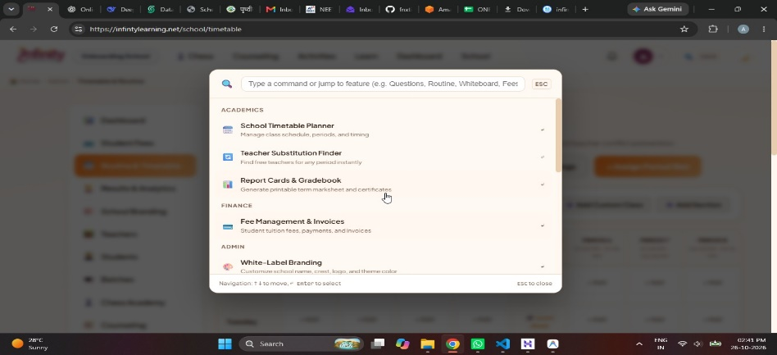

- In fee recipt need to add all different types of part that leads to the total amount fee breakdown, also the principle signature that I uploaded need to see in the authorized signatory, or the authorized person can also upload their image so we need to create a new upload system where the authorized person can upload their signature and is reflected on the reciept page.
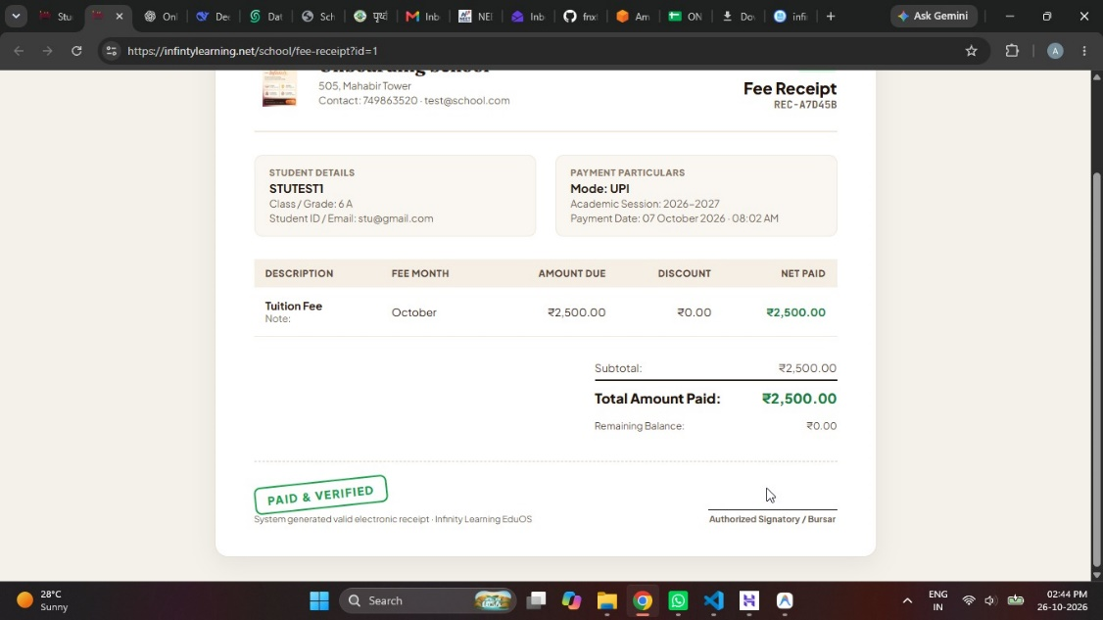

- is different it should be in order from 1 and move frowerd form there (also in student).
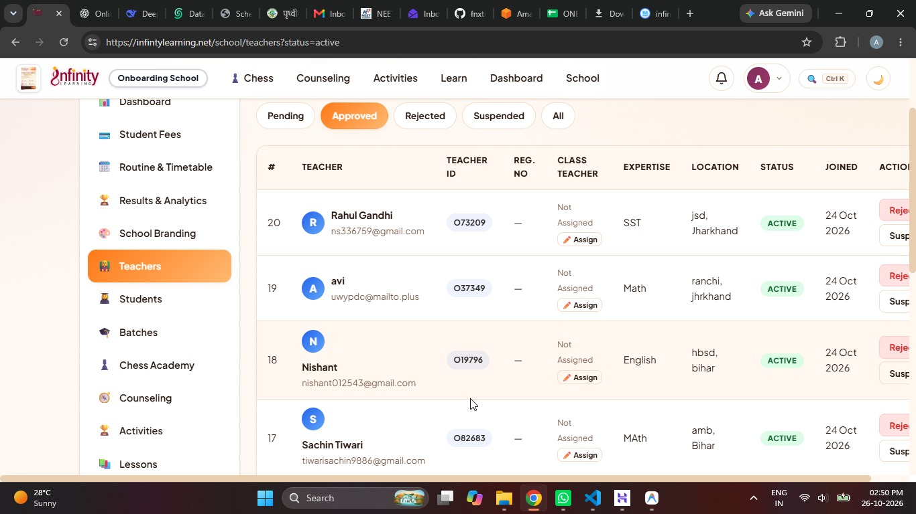
- Batches can be only created by admin and not teacher also change the name form batch to class and I cannot see the different batch which is already present.
The the function of batch can be edited and changed by admin only.
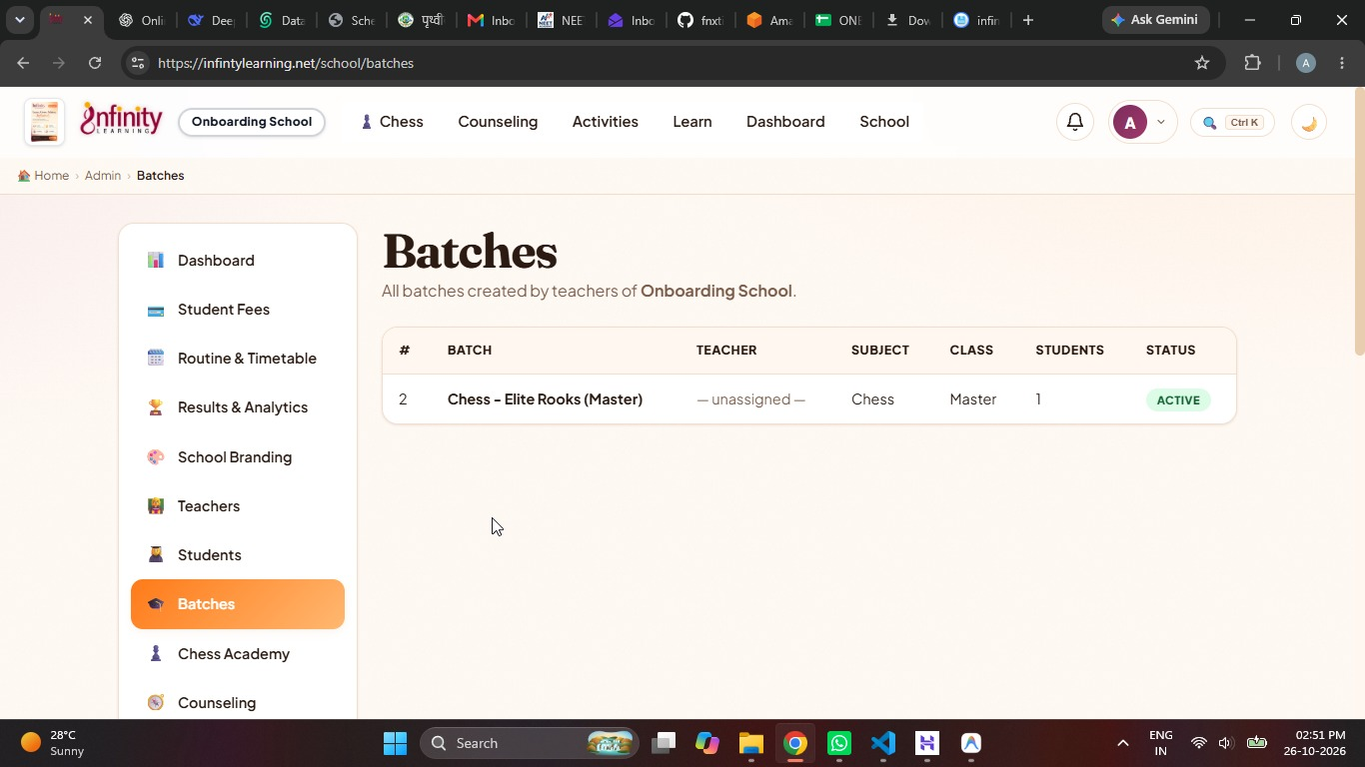

- Admin can change the student details when they click on view they should get an option of edit profile of each and every student.
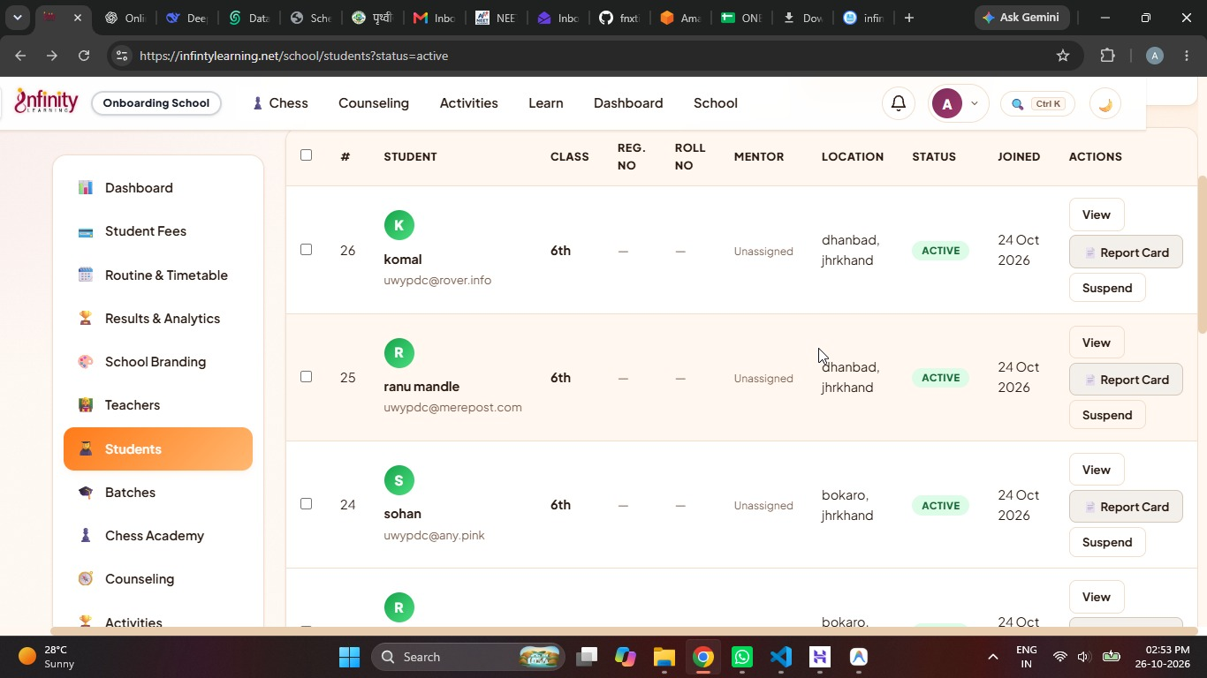
- The developemnt profile works perfectly on admin but not from student dashboard make sure it works properly.
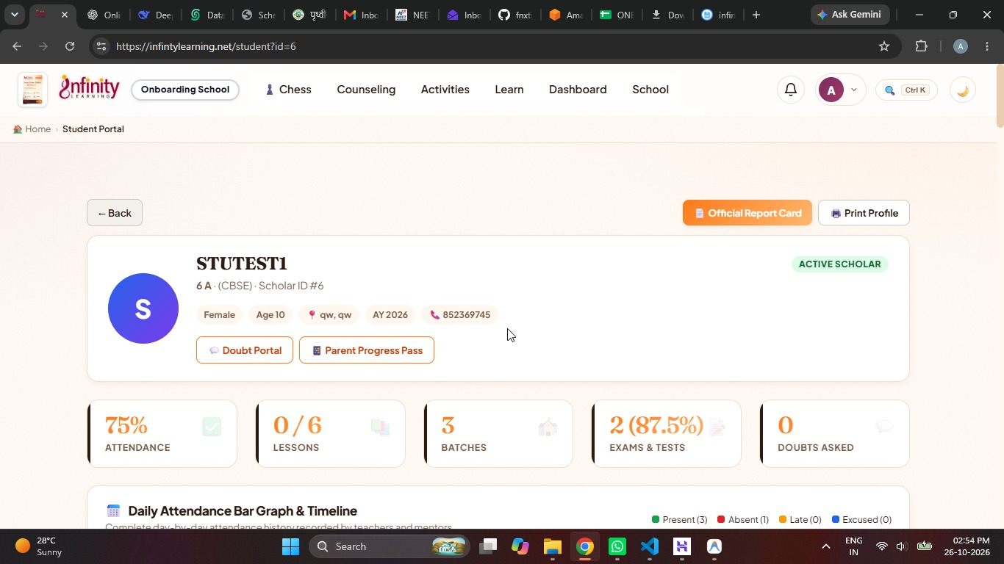

Teacher
- Same issue the top of the box get cut it need to be above the nav bar.
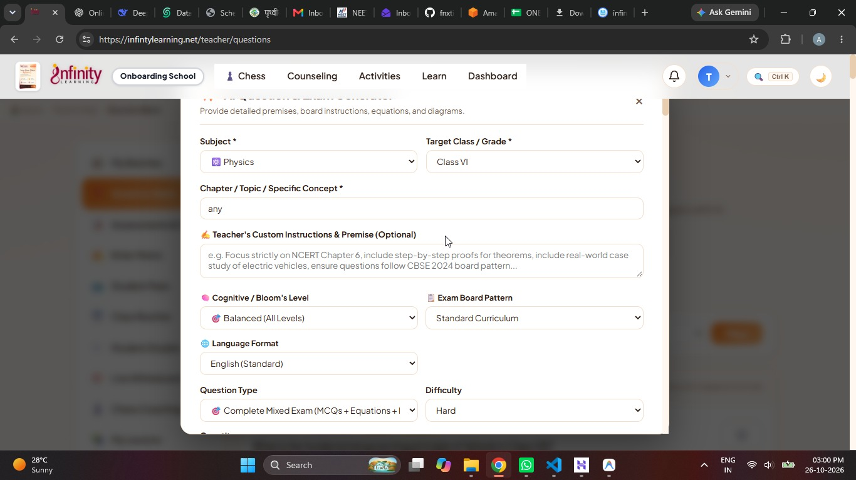
- when click on +create/..... we can create new assessment.
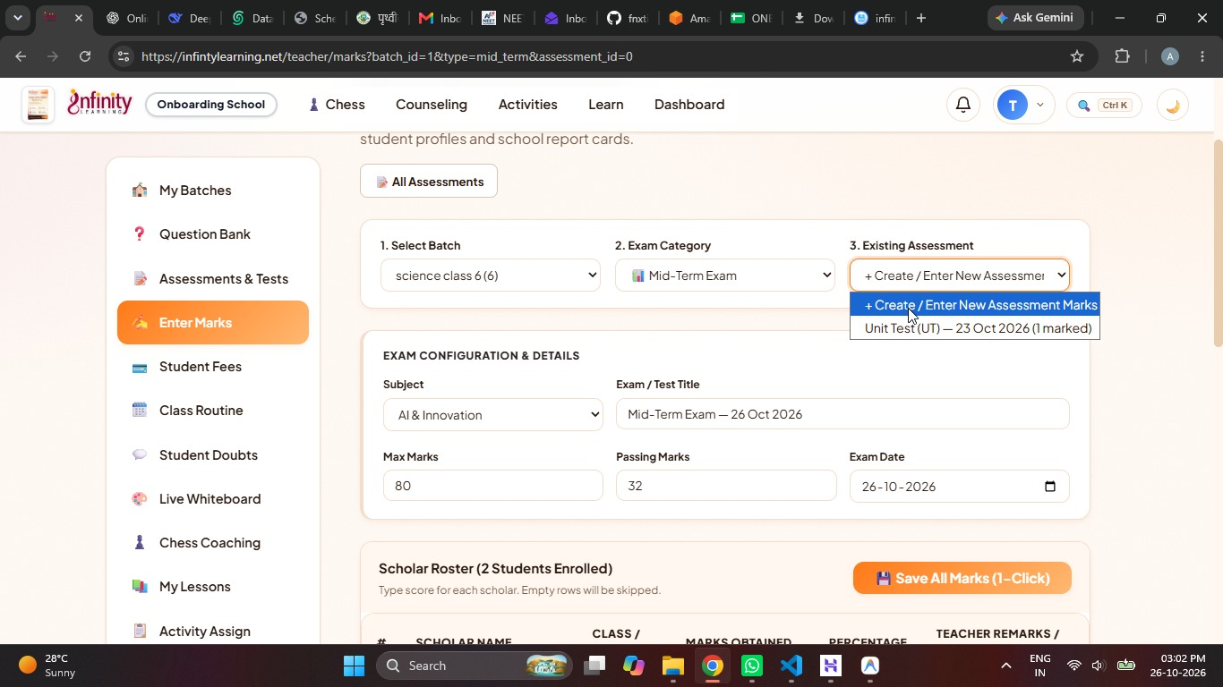
- In teacher profile we need to add a button to let teacher upload their signature, insted of head of academy it will be principle signature and it will populate autometaclly.
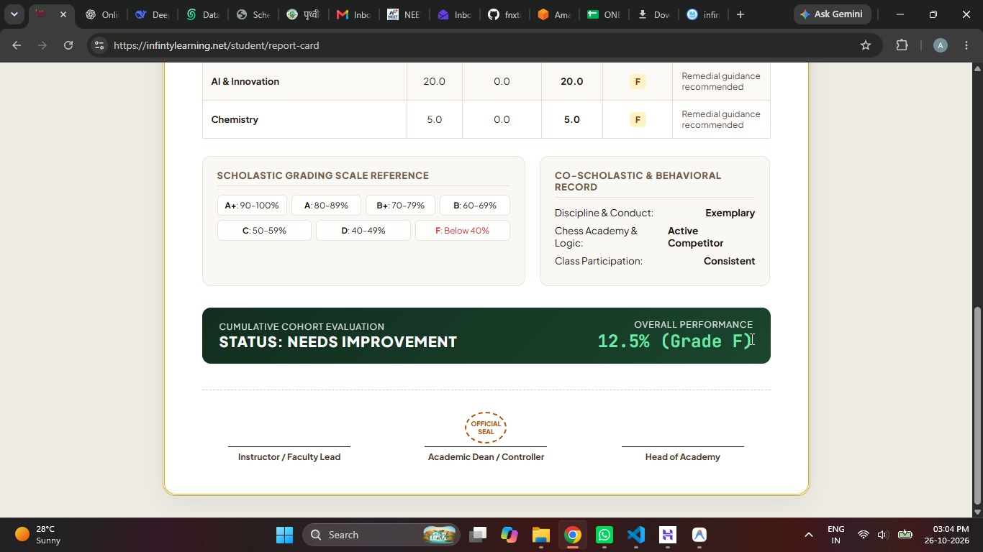

Student.
- This is student dashboard
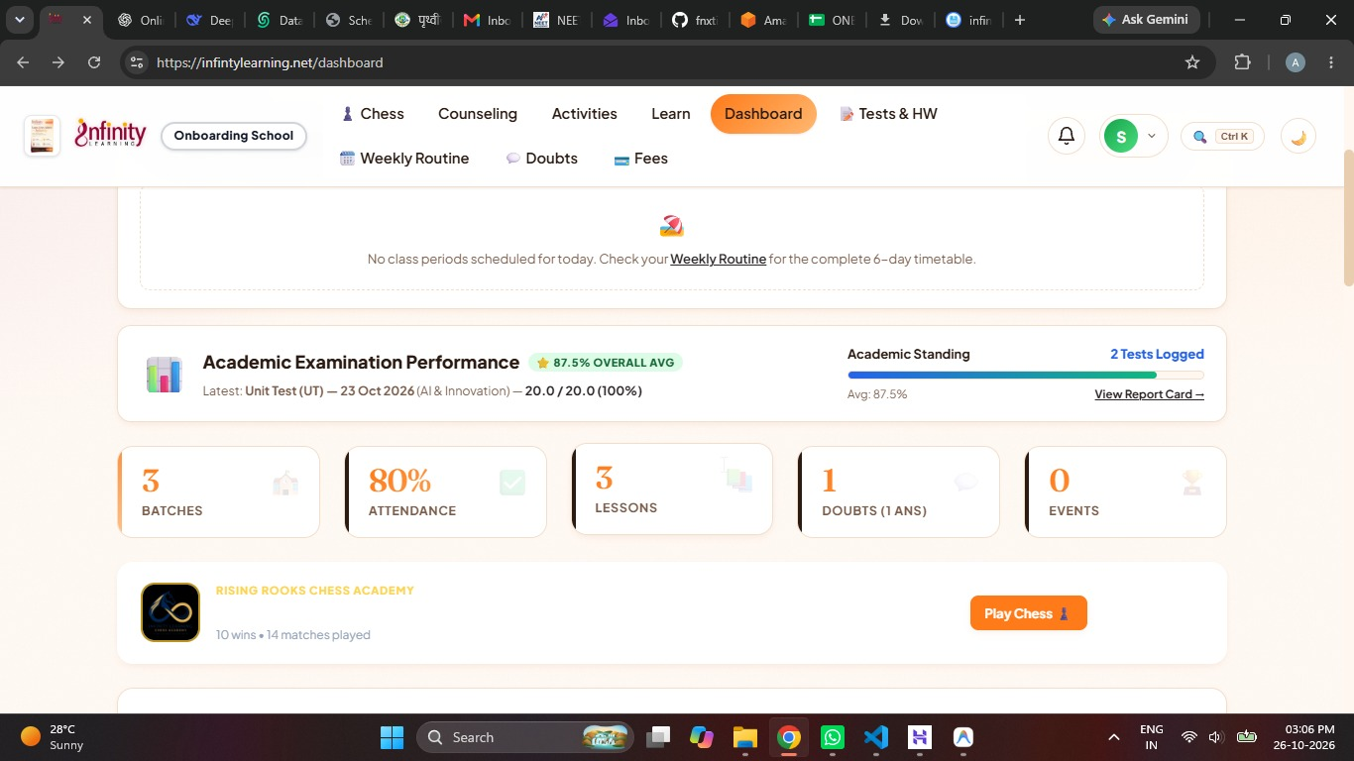

- But in student developemnt profile I cannot see any details.
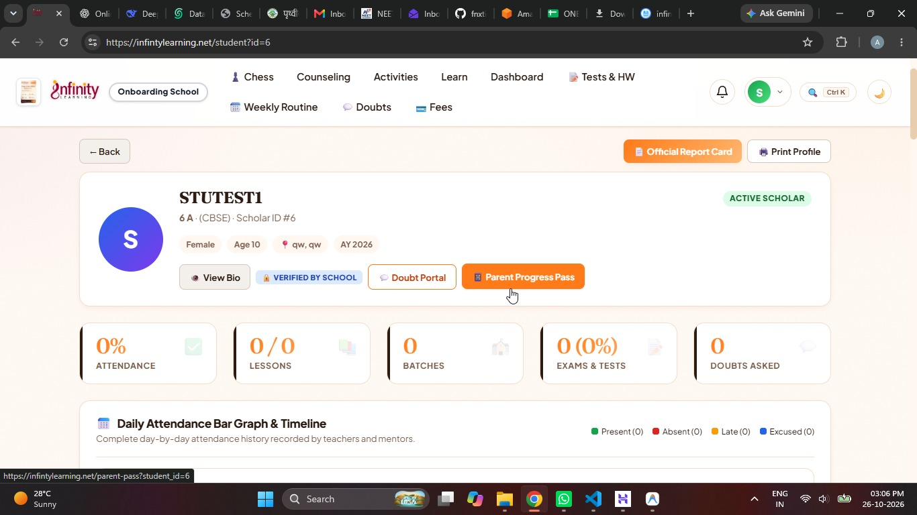
- In parent pass we do not need routine insterd this will be the gaph of marks trend and the attendance will be also in graph formate (bar).
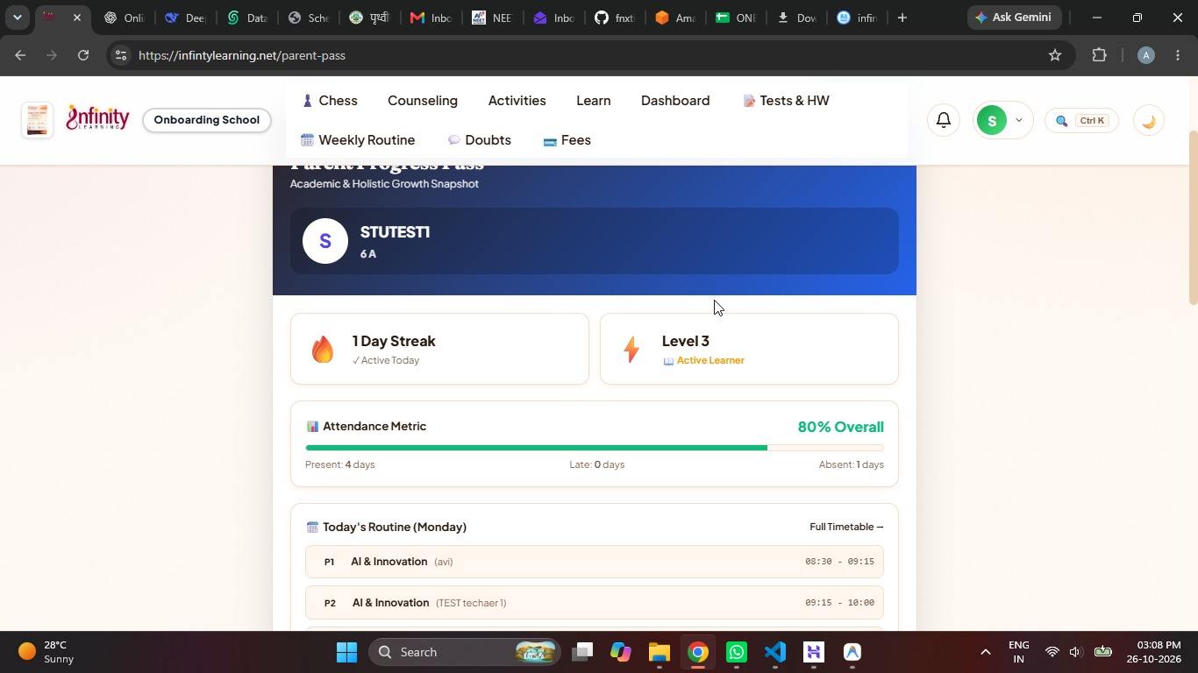
- From bar graph the word will be graph.

